
This document and its contents are copyright of Centro ASSIST© 2020. All rights reserved.
Any redistribution, retransmission or distribution of part or all of the contents in any form without our express written permission is prohibited other than the following:

- you may share and use with your clients, NDIS participants, to aid communication
- you may share and use with employees to assist in their work
© 2020 Holocentric Pty Ltd, trading as Centro ASSIST
ABN 73 052 972 095

Incident management policy
Easy English Version
Prepared by Centro ASSIST

Version 2.0

Incident management policy
 |  | About this document  Knoxbrooke will always respond to and resolve incidents. Our goal is to make sure that you are happy and safe.
 | This document will help you to understand:  - how to recognise an incident  - how to get help  - how we respond to incidents  - what information we will need from you  - how we will help if you are part of an incident.

 | What is an incident?  An incident is when something goes wrong. It usually means that something bad happened to you or someone else.  There are many types of incidents. Some examples are:
 | - a person experiencing harm of any type of harm or abuse (see Abuse, neglect and exploitation easy read)
 | - loss or damage of property
 | - a near miss that could have caused harm
 | - taking the wrong medications

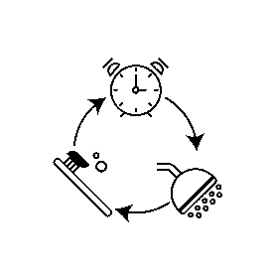 | - harmful changes to usual support routines
 | - illegal activities (e.g. theft or drug use).

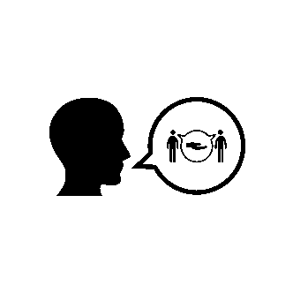 | How to get help?  If you experience an incident or believe someone else may have experienced an incident, you should let us know. This is called reporting.  You can report an incident at any time. We will help you to do this.
 | Family members, advocates or friends can also help you to report an incident.
 | You can report an incident by:  - letting a worker know about the situation  - sending an email  - making a phone call.
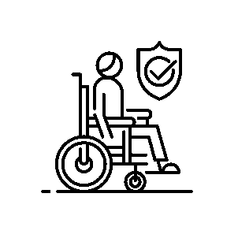 | If you believe we did not sort out the incident well, you can make a complaint to the NDIS. We will help you if you decide to do this.

 | How we respond to incidents  Once we know about an incident we will respond immediately, if possible. If we cannot do this immediately, we will let you know when and how we will respond.
 | Knoxbrooke will make sure that all our workers know how to respond to incidents.
 | Less serious incidents will be resolved by us. We will work with you and any other people involved.
 | We might also tell your friends and family about incident and ask them to help.

 | If an incident is serious we will involve other organisations to help us resolve it. This is called escalation.  Depending on the type of incident, we might need to escalate it by contacting:  - the NDIS Quality and Safeguards Commission  - the police  - an external investigator  - other support services (for example, a doctor or counsellor).

 | What information will we need?  To resolve an incident we need to write down what happened and what we did to help. This is called keeping records.
 | To keep good records Knoxbrooke will need to ask you about the incident. We might ask questions like:  - What happened?  - At what time did it happen?  - Where did it happen?  - Who was involved?
 | If you are uncomfortable sharing information with us at any time, please let us know.
 | Records about what happened will be kept for at least 7 years after the incident.

 | How will we help you?  Knoxbrooke will always uphold your rights and ensure that you are safe.
 | Knoxbrooke will give you the help you need if you are affected by an incident.  For example: If you are stressed because of an incident, we can provide a counsellor who will help you to feel better.
 | If needed, we will discipline any people that did the wrong thing.  For example: If a worker caused harm to you or others, they will not work with us again.
 | Knoxbrooke will check that we resolved the incident properly.  If needed, we will change how we do things to improve our services and make sure the incident will not happen again.

